STORYTELLING TILES ASSIGNMENT
Tile Specifications: 3 tile triptych- horizontal or vertical – 4x4 (4x12 overall design)
NO LARGER OR SMALLER
ALL TILES MUST RELATE/CONNECT TO ONE ANOTHER
STORYTELLING TILES ASSIGNMENT:
A. Brainstorming List: (make a list)
• Imaginary, realistic, abstract, fantasy, “real-world”, dreams, fictional, etc.
• Landscapes, moonscapes, seascapes, etc.
• People, animals, objects, lettering, architecture, weather, plant life, “habitats”- mountains, hills, oceans, jungle, desert, etc.
• Vacations, important events, important people or moments, memories, about you…

B. Write a Paragraph :
• Choose your favorite concept/story that you are going to illustrate. Write at least 3 complete sentences describing it.

C. Sketching Directions:
• Complete 2 sketches illustrating your ideas on the paper provided.
• The finished design should tell a personal story about a dream, a memorable event, or an important person. It should include small, medium, and large images, as well as a foreground, middleground and background.
• Draw detail, texture, and lines, where appropriate.
• Work on one side of the paper only.

D. Discuss your favorite design with the teacher

E. Color with colored pencil how you plan to decorate the tiles:

Things I have to include in my sketches:
• 2 large sketches on paper provided
• Foreground, Middle ground, background (3 layers of relief)
• At least 5 “objects” or “pieces”
• Create a border or edge
• Create a tile triptych that tells a story or conveys a story to the viewer.

IMPORTANT VOCABULARY WORDS:
Composition- the arrangement of the parts in a work of art, usually according to the principles of design.

Relief- a three-dimensional form, meant to be seen from one side, in which surfaces project from a
background. In high relief, the forms stand far from the background. In low relief, also known as bas-relief,
they are shallow.

• Additive relief- when an image is added above the original surface or the background (adding coils, cut-out shapes, or modeling).

• Subtractive relief- when an image is molded below the original surface or the background (carving into the piece, taking away).

• Sunken relief- when and image is molded below the original surface or the background (objects pressed in to surface or stamping).

Foreground- objects that appear closets to the viewer, most often larger than those that are behind.

Middle ground- objects that appear between the foreground and the background.

Background- objects that appear farthest from the viewer, most often smaller than those that are in front.

Below, label foreground, middle ground, & background as discussed in class:
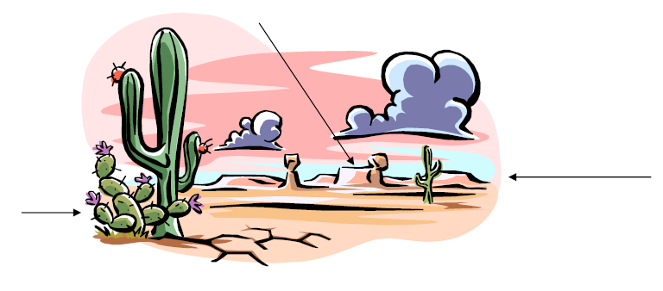
Realistic art- art that shows recognizable subject with lifelike colors, textures, shadows, and proportions.

Abstract Art- a style of art that objects, people, and/or places are simplified arrangements of shape, line,
texture, and color, often geometrical.
Texture- the perceived surface quality of an artwork.
Imagery- the use of expressive images in art.
Symbolism- the use of recurrent symbols or images in a work to create an added level of meaning.
Triptych- art consisting of a painting or carving on three panels.
Incise- to cut in or into with a sharp instrument; to carve; to engrave

The Process:
1.) Transfer your design to the clay tiles using the method demonstrated in class.
2.) Begin adding clay to build the higher relief areas of your design.
3.) Once you have added all the high relief areas and your clay is leather hard, begin using the available tools
to carve lines, textures and details into the clay.
Use a rigid, dry paint brush to remove the excess clay as you carve.
4.) Smooth the edges and backs of the tiles using a sponge or your fingers when you are finished carving.
5.) You may lightly smooth your carved areas as well.
6.) Make sure to create some way to hang the tile on the back
7.) Your tiles should dry slowly on pieces of drywall to ensure that they dry flat and to avoid cracking.
8.) Paint your tiles using underglaze

Assessment:
Both your sketches and final design will be graded on the following:

-Choice of theme
-Choice of imagery/symbols
-Use of small, medium, and large images
-Development of foreground, middleground, and
background
-Composition
-Craftsmanship
-Execution of relief – development of both high and
low relief
-Addition of texture
-Tiles are of equal size and remained flat after
drying and firing
-Tiles are unified/related
-Appropriate color choices

