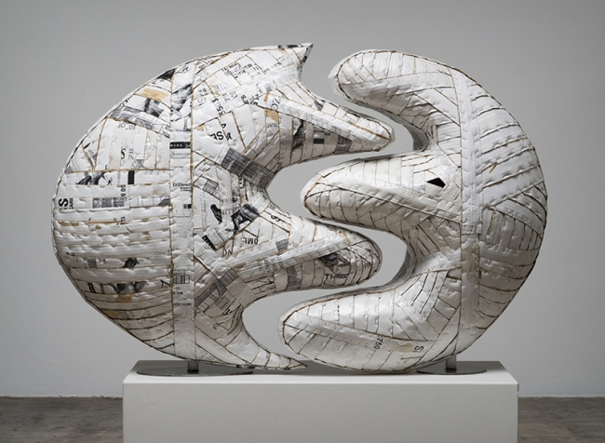
Ann Weber Sculpture - Final Assessment
Name: Period:
Project Assessment (40 point):
 | 1 | 2 | 3 | 4 | 5
Idea & Interpretation | Your design is not powerful, creative and appropriately interpreted | Your design is only slightly powerful, creative and appropriately interpreted | Your design is somewhat powerful, creative and appropriately interpreted | Your design is mostly powerful, creative and appropriately interpreted | Your design is powerful, creative and appropriately interpreted
Skeleton construction | Your construction is not neat and sturdy | Your construction is only slightly neat and sturdy | Your construction is somewhat neat and sturdy | Your construction mostly is neat and sturdy | Your construction is neat and sturdy
Surface construction | Your surface construction is not neat and sturdy | Your surface construction is only slightly neat and sturdy | Your surface construction is somewhat neat and sturdy | Your surface construction mostly is neat and sturdy | Your surface construction is neat and sturdy
Surface Material & Design | Your surface material and design application does not enhanced you design | Your surface material and design application only slightly enhanced you design | Your surface material and design application somewhat enhanced you design | Your surface material and design application mostly enhanced you design | Your surface material and design application enhanced you design
Surface Finishing | You did not complete your finishing treatment | You completed your finishing treatment but it was not neat or complete | Your finishing treatment was neat and complete with major areas of imperfections | Your finishing treatment was neat and complete with minor areas of imperfections | Your finishing treatment was neat and complete

Used time, care & effort | You did not utilize your time in class productively | While you were somewhat productive in class you could have used much more of your time | While you had times that were productive, you had many times that you did not utilize your time well | You had times that were productive with some minor distractions | You made productive use of every available moment in class
Listened and were silent during instruction | You were distracting while instructions were being given | You were somewhat attentive but also distracted / talking | You were attentive but missed some elements due to being distracted | You were mostly attentive with minor distractions | You were attentive while instruction were given
Followed rules, team tasks & clean up | You did not follow through with task/clean up or broke rules | You mostly followed rules and task/clean up | You followed rules and completed somewhat of your tasks/clean up | You followed rules and completed most of your tasks/clean up | Not only did you follow rules/tasks, but you also went above and beyond to be helpful

