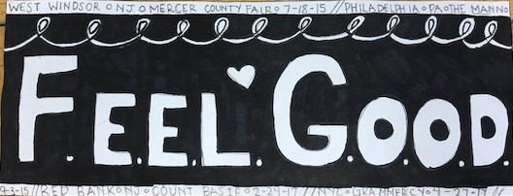

Sgraffito Vessel Design

Name: Class:

Place a CHECK on the score you feel you deserve

10 = Excellent, 8 = Good, 6 = Average, 4 = could improve, 2 = insufficient effort, 0 = didn’t do

Project Results - 20 Points  - You completed your sgraffito design  - Your design is approximately 50% black and 50% white  - You colored in all of your black areas to indicate where the glaze will be located  - You have an appropriate level of detail in your design | 0 1 2 3 4 5  0 1 2 3 4 5  0 1 2 3 4 5  0 1 2 3 4 5
Classroom Participation - 15 Points  - You used your time well and did your work with care and effort  - You listened and were silent during instruction  - You followed rules, team tasks & clean up | 0 1 2 3 4 5  0 1 2 3 4 5  0 1 2 3 4 5

