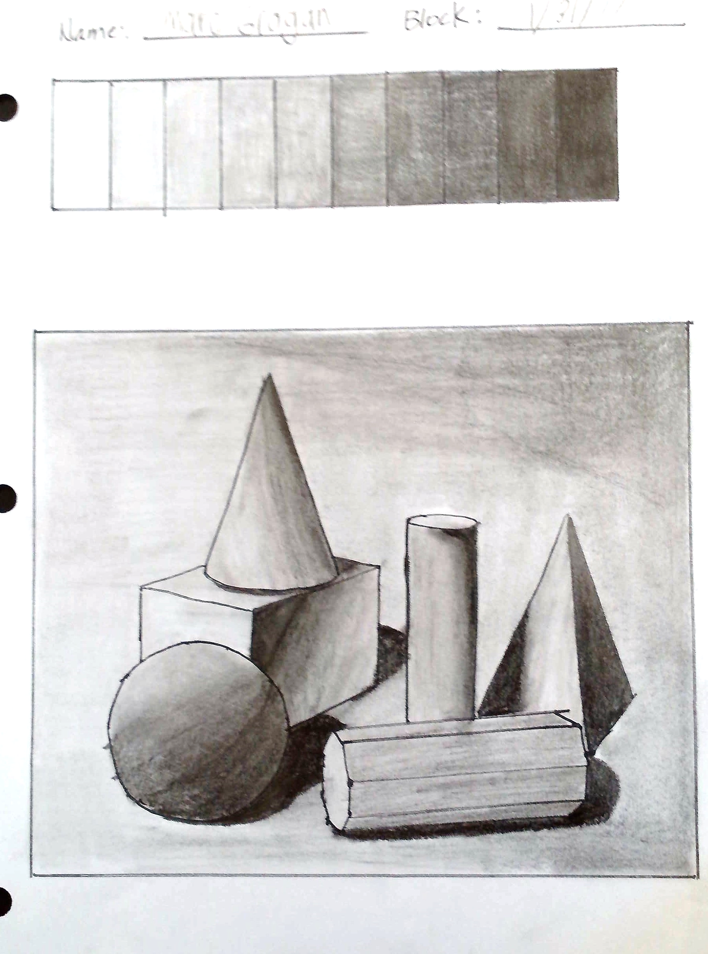
VALUE Assessment
Name: Period:
Assessment (40 point):
 | 1 | 2 | 3 | 4 | 5
Completeness | You did not do the exercises | One exercises was completed | Two exercises were completed | Three exercises were completed | All four exercises were completed
Value scale | Little effort was made and drawing is lacking definition of objects | Your value scale represents only slightly the full range from black to white in equal intervals and completely blended (no jumps) | Your value scale represents somewhat the full range from black to white in equal intervals and completely blended (no jumps) | Your value scale represents most of the range from black to white in equal intervals and completely blended (no jumps) | Your value scale represents the full range from black to white in equal intervals and completely blended (no jumps)
Drawing – full value scale | You have less than 30% of the value scale represented | You have about 40% of the value scale represented | You have about 60% of the value scale represented | You have most of the full value | Your darks and lights represent the full range of the value scale
Drawing – value placement | Your values are not in the correct placement/  proportion | Your values are only slightly in the correct placement/proportion | Your values are somewhat in the correct placement/proportion | Your values are mostly in the correct placement/proportion | Your values are in the correct placement/proportion
Drawing - Blending | You did not blend effectively | While you have some blending, you have many areas that are not blended or have “jumps” | You are mostly blended with some areas of “jumps” or unblended lines | You blended accurately with only minor areas of ”jumps” | Your drawing is beautifully blended to create smooth form

Time on Task | You did not utilize your time in class productively | While you were somewhat productive in class you could have used much more of your time | While you had times that were productive, you had many times that you did not utilize your time well | You had times that were productive with some minor distractions | You made productive use of every available moment in class
Effort and Perseverance | You did not continued to persevere and gave up without exhausting resources | You only slightly continued to persevere and apply consistent effort in order to achieve goal using resources as needed | You mostly continued to persevere and apply consistent effort in order to achieve goal using resources as needed | You somewhat continued to persevere and apply consistent effort in order to achieve goal using resources as needed | You continued to persevere and apply consistent effort in order to achieve goal using resources as needed
Class rules & clean up | You did not follow through with task/clean up or broke rules | You mostly followed rules and task/clean up | You followed rules and completed somewhat of your tasks/clean up | You followed rules and completed most of your tasks/clean up | Not only did you follow rules/tasks, but you also went above and beyond to be helpful

