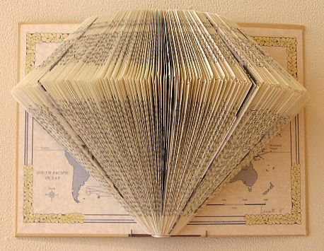  - 1 Point  - Above center  - Point stay even  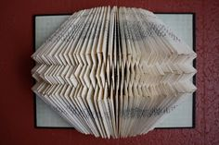  - 3 Points  - Center, top & bottom  - Points stay even | 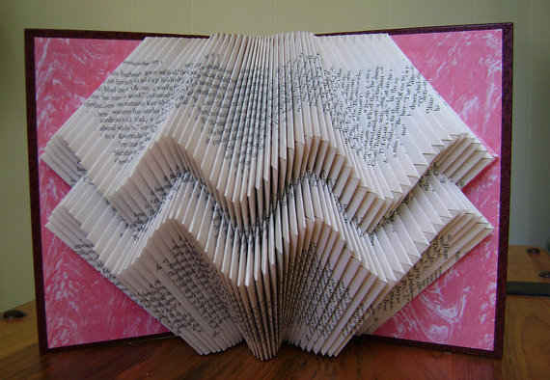  - 2 Points  - Above & below center  - Point move up & down  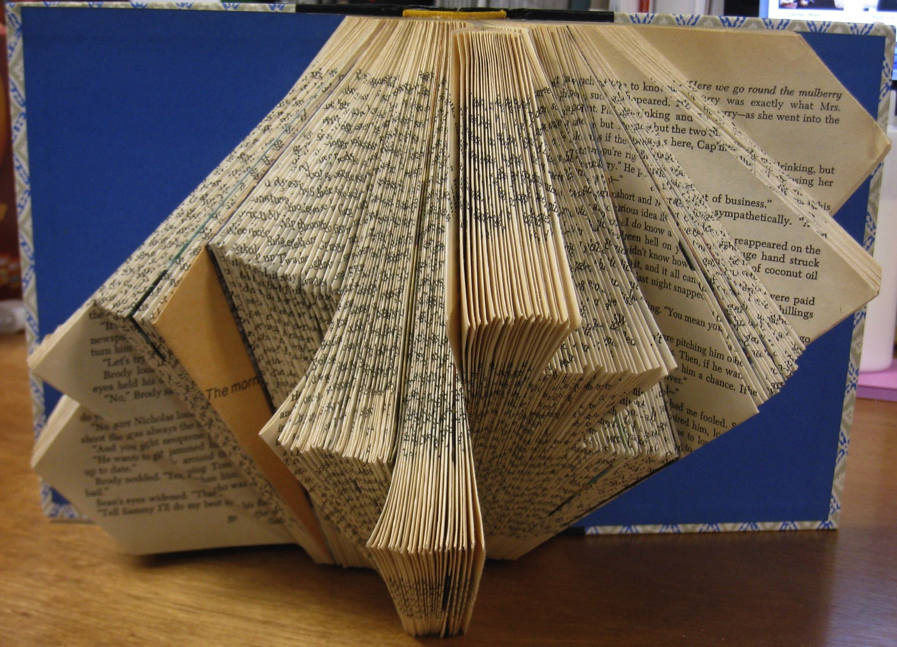  - Many Points  - Point are all different levels  - Points stay even within section

Name:_________________________________________ Period: ____________________________

Book Sculpture Worksheet

- How many pages are in your book? ______________

- Total number of pages ________ divided by 2 = _______________

__________________________________________________________________________________________________________________

- How many “points” do you want on your scupture?

- Where will the points be located?

- Will they stay level or move around?

Draw the line that represents your points on your book

Example:

Your drawing here:

