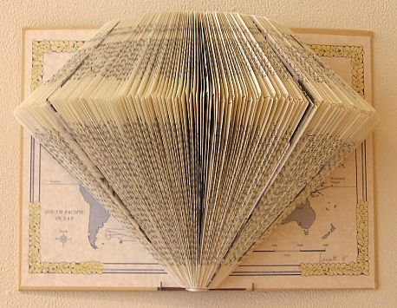
Book Sculpture
Final Assessment
Name: Period:

Book Sculpture Assessment (35 point):
 | 1 | 2 | 3 | 4 |  | 5
Worksheet | Incomplete and done with little care | Somewhat complete but lacking some effort | Mostly complete but lacking care and effort |  | Complete with minor mistakes | Completed 100% with care and effort
Completeness | Completed approx. 20% | Completed approx. 40% | Completed approx. 60%. |  | Completed approx. 80%. | Completed 100% , all of your pages
Design Impact | Your design does not utilize the 3D potential of the book | Your design shows some form, but does not maximize the 3D qualities of the book | Your design shows form but is not unique |  | Your design shows form and is somewhat unique and creative | Your design not only shows form, but is unique and creative
Consistency | Significant inconsistencies exist and are distracting | Several areas are “jumpy” and distracting | Significant areas of consistencies exist with some areas of distraction |  | Most areas of consistencies exist with some minor areas of distraction | You have consistencies in all areas

Used time, care & effort | You did not utilize your time in class productively | While you were somewhat productive in class you could have used much more of your time | While you had times that were productive, you had many times that you did not utilize your time well | You had times that were productive with some minor distractions | You made productive use of every available moment in class
Listened and were silent during instruction | You were distracting while instructions were being given | You were somewhat attentive but also distracted / talking | You were attentive but missed some elements due to being distracted | You were mostly attentive with minor distractions | You were attentive while instruction were given
Followed rules, team tasks & clean up | You did not follow through with task/clean up or broke rules | You mostly followed rules and task/clean up | You followed rules and completed somewhat of your tasks/clean up | You followed rules and completed most of your tasks/clean up | Not only did you follow rules/tasks, but you also went above and beyond to be helpful

