Study Guide: Fine Arts 2017-18
Definitions
A value scale  Contour line  Value  Blind contour drawing  Variation  Complementary color  Focal point  Elements of Art  Principles of Art  Grid  Shape  Primary colors  Negative Space  Art  Perspective | Two dimensional closed area  Blue, red, yellow  Techniques to represent objects in distance  Full range of values from dark to light intervals  Place where the viewer focuses  Opposite sides of the color wheel  Line, shape, form, value, texture. color & space  Line showing outside edge or detail  Aid to draw images accurately and/or in a different size  A creative effort in recording human existence and thought  Level of darks and lights  Line created without looking at paper  Use of different lines, shapes, textures & colors  Balance, unity. Movement, proportion, variety and emphasis  Area around an object or shape

Definitions - answers
A value scale  Contour line  Value  Blind contour drawing  Variation  Complementary color  Focal point  Elements of Art  Principles of Art  Grid  Shape  Primary colors  Negative Space  Art  Perspective | Full range of values from dark to light intervals  Line showing outside edge or detail  Level of darks and lights  Line created without looking at paper  Use of different lines, shapes, textures & colors  Opposite sides of the color wheel  Place where the viewer focuses  Line, shape, form, value, texture. color & space  Balance, unity. Movement, proportion, variety and emphasis  Aid to draw images accurately and/or in a different size  Two dimensional closed area  Blue, red, yellow  Area around an object or shape  A creative effort in recording human existence and thought  Techniques to represent objects in distance

A value scale  Contour line  Value  Blind contour drawing  Variation  Complementary color  Focal point  Elements of Art  Principles of Art  Grid  Shape  Primary colors  Negative Space  Art  Perspective | 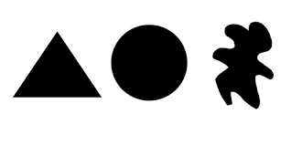  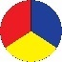  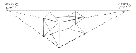  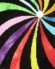  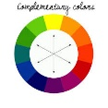  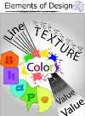  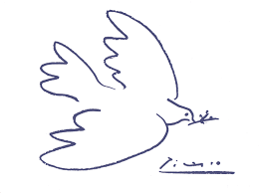  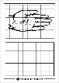  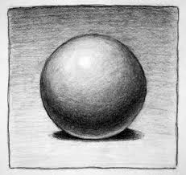  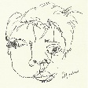  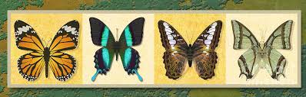

A value scale

Contour line

Value

Blind contour drawing

Variation

Complementary color

Focal point 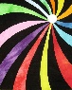

Elements of Art

Principles of Art

Grid

Shape

Primary colors

Negative Space

Art

Perspective

