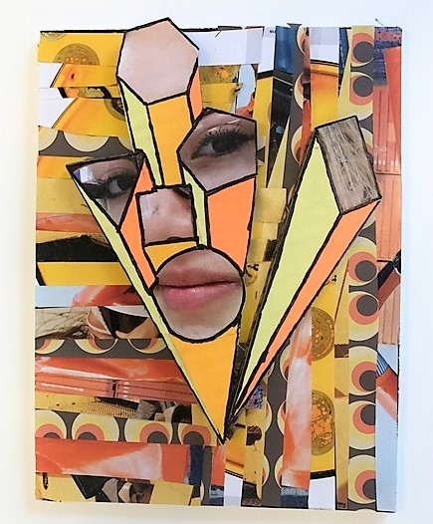
One Point Perspective Exploding Portraits
Final Assessment
Name: Period:

Project Assessment (40 point):
 | 1 | 2 | 3 | 4 |  | 5
Technique | Your perspective technique is inaccurate and done with little care | Your perspective technique is somewhat accurate but had some major inaccuracies | Your perspective technique is somewhat accurate. |  | Your perspective technique complete and accurate with minor mistakes | Your perspective technique is complete and fully accurate
Completeness | Completed approx. 20% | Completed approx. 40% | Completed approx. 60%. |  | Completed approx. 80%. | Completed 100% , all of your pages
Color Scheme and Value placement | You do not have a clear color scheme and your value placement does not enhances your 3D effect | You have an only slightly clear color scheme and your value placement only slightly enhances your 3D effect | You have a somewhat clear color scheme and your value placement somewhat enhances your 3D effect |  | You have a mostly clear color scheme and your value placement mostly enhances your 3D effect | You have a clear color scheme and your value placement enhances your 3D effect
Background | Your background is not neat, creative and/or does not follows your color scheme | Your background is only slightly neat, creative and follows your color scheme | Your background is somewhat neat, creative and follows your color scheme |  | Your background is mostly neat, creative and follows your color scheme | Your background is neat, creative and follows your color scheme
Craftsmanship | You took little effort in creative your work | Your craftsmanship is detracts from your work | Your craftsmanship is decent with some imperfections |  | Your craftsmanship is good with minor imperfections | Your craftsmanship is perfect

Used time, care & effort | You did not utilize your time in class productively | While you were somewhat productive in class you could have used much more of your time | While you had times that were productive, you had many times that you did not utilize your time well | You had times that were productive with some minor distractions | You made productive use of every available moment in class
Listened and were silent during instruction | You were distracting while instructions were being given | You were somewhat attentive but also distracted / talking | You were attentive but missed some elements due to being distracted | You were mostly attentive with minor distractions | You were attentive while instruction were given
Followed rules, team tasks & clean up | You did not follow through with task/clean up or broke rules | You mostly followed rules and task/clean up | You followed rules and completed somewhat of your tasks/clean up | You followed rules and completed most of your tasks/clean up | Not only did you follow rules/tasks, but you also went above and beyond to be helpful

