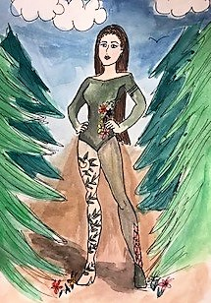
Superhero Assessment
Name: Period:
Project Assessment (35 point):
 | 1 | 2 | 3 | 4 | 5
Worksheet | You did not do a worksheet | You only slightly completed your worksheet | You somewhat completed your worksheet | You mostly completed your worksheet | You thoroughly completed your worksheet
Idea development | You did not develop your ideas | While you slightly developed your idea, it is not clear | While you developed your idea, is not clear | You mostly developed your idea to clearly communicate a vision | You fully developed your idea to clearly communicate a vision
Rendering and coloring | Your execution was not neat, fully colored and did not enhances your design | Your execution was only slightly neat, fully colored and only slightly enhances your design | Your execution was somewhat neat, fully colored and somewhat enhances your design | Your execution was mostly neat, fully colored and mostly enhances your design | Your execution was neat, fully colored and enhances your design
Background | Your background is not completed | Your background is only slightly active and only slightly enhances your image | Your background is somewhat activated and somewhat enhances your image | Your background is mostly activated and mostly enhances your image | Your background is fully activated and enhances your image

Used time, care & effort | You did not utilize your time in class productively | While you were somewhat productive in class you could have used much more of your time | While you had times that were productive, you had many times that you did not utilize your time well | You had times that were productive with some minor distractions | You made productive use of every available moment in class
Listened and were silent during instruction | You were distracting while instructions were being given | You were somewhat attentive but also distracted / talking | You were attentive but missed some elements due to being distracted | You were mostly attentive with minor distractions | You were attentive while instruction were given
Followed rules, team tasks & clean up | You did not follow through with task/clean up or broke rules | You mostly followed rules and task/clean up | You followed rules and completed somewhat of your tasks/clean up | You followed rules and completed most of your tasks/clean up | Not only did you follow rules/tasks, but you also went above and beyond to be helpful

