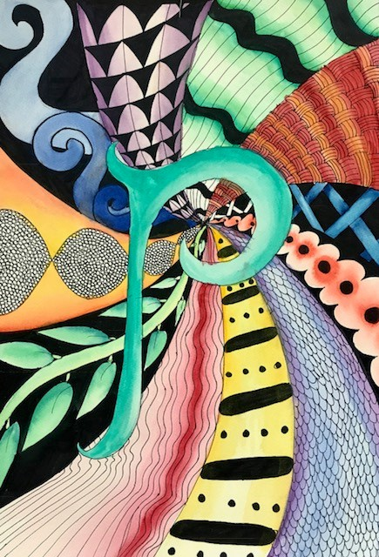
Zentangle Assessment
Name: Period:
Project Assessment (35 point):
 | 1 | 2 | 3 | 4 | 5
Completeness | Completed approx. 20% of the painting | Completed approx. 40% of the painting | Completed approx. 60% of the painting | Completed approx. 80% of the painting | Completed 100% of the painting
Zentangle craftsmanship | Your zentangles are not constructed correctly or neatly | Your zentangles are only somewhat constructed correctly and neatly | Your zentangles are mostly constructed correctly and neatly | Your zentangles are constructed correctly and neatly | Your zentangles are constructed perfectly and your explored new creative designs
Overall composition | You did not created a composition | You slightly created a composition with eye movement | You somewhat created a good composition with eye movement | You created a good composition with eye movement | You created a pleasing composition with extensive eye movement
Color application (Hue, Tint, shade & complementary) | You did not created an effective use of all aspects of color | You only slightly created an effective use of all aspects of color | You created a somewhat effective use of all aspects of color | You created a mostly effective use of all aspects of color | You created an effective use of all aspects of color

Used time, care & effort | You did not utilize your time in class productively | While you were somewhat productive in class you could have used much more of your time | While you had times that were productive, you had many times that you did not utilize your time well | You had times that were productive with some minor distractions | You made productive use of every available moment in class
Listened and were silent during instruction | You were distracting while instructions were being given | You were somewhat attentive but also distracted / talking | You were attentive but missed some elements due to being distracted | You were mostly attentive with minor distractions | You were attentive while instruction were given
Followed rules, team tasks & clean up | You did not follow through with task/clean up or broke rules | You mostly followed rules and task/clean up | You followed rules and completed somewhat of your tasks/clean up | You followed rules and completed most of your tasks/clean up | Not only did you follow rules/tasks, but you also went above and beyond to be helpful

