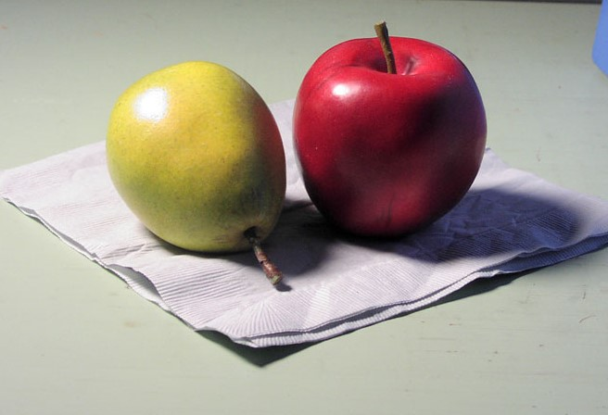
Acrylic Fruit Assessment
Name: Period:
Acrylic Assessment (30 point):
 | 1 | 2 | 3 | 4 | 5
Completeness | Completed approx. 20% of the painting | Completed approx. 40% of the painting | Completed approx. 60% of the painting | Completed approx. 80% of the painting | Completed 100% of the painting
Value Accuracy | You did not accurately represented your values in the correct places and proportions | You only slightly accurately represented your values in the correct places and proportions | You somewhat accurately represented your values in the correct places and proportions | You mostly accurately represented your values in the correct places and proportions | You accurately represented your values in the correct places and proportions
Blending | Your blending of paint is not complete and accurate | Your blending of paint is only slightly complete and accurate | Your blending of paint is somewhat complete and accurate | Your blending of paint is mostly complete and accurate | Your blending of paint is complete and accurate

Time on task | You did not utilize your time in class productively | While you were somewhat productive in class you could have used much more of your time | While you had times that were productive, you had many times that you did not utilize your time well | You had times that were productive with some minor distractions | You made productive use of every available moment in class
Listened and were silent during instruction | You were distracting while instructions were being given | You were somewhat attentive but also distracted / talking | You were attentive but missed some elements due to being distracted | You were mostly attentive with minor distractions | You were attentive while instruction were given
Followed rules, team tasks & clean up | You did not follow through with task/clean up or broke rules | You mostly followed rules and task/clean up | You followed rules and completed somewhat of your tasks/clean up | You followed rules and completed most of your tasks/clean up | Not only did you follow rules/tasks, but you also went above and beyond to be helpful

