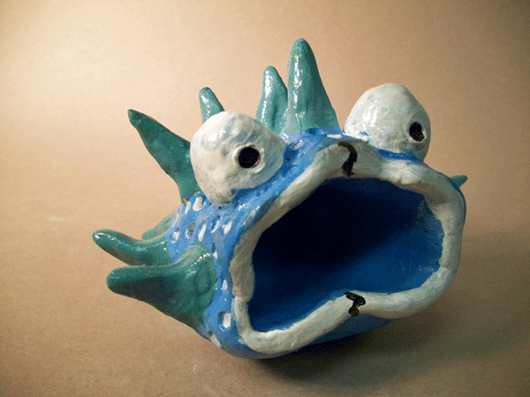
Air Clay Fish Sculpture
Final Assessment
Name: Period:

Project Assessment (35 point):
 | 1 | 2 | 3 | 4 |  | 5
Pinch pot base | You did not create a pinch pot base | You base utilized pinch pot technique but is not consistent | You base utilized pinch pot technique but has some consistencies |  | Your base is overall correct with some inconsistencies | Your pinch pot base is perfectly made
Added pieces | You did not add extra pieces | You added less than three pieces | You added three pieces |  | You added four pieces | You added more pieces that required to enhance our design
Texture & Detail | You did not apply texture & detail | Partial texture & detail was added | While you applies some texture and detail, more could be utilized |  | Your texture and detail enhances your image but not fully | Your texture and detail enhances you work
Creativity | You work is solid but lacks unique qualities | Your work has mostly common elements | Your work has some unique qualities |  | Your work is mostly unique with some common elements | Wow! This is such a unique and great idea!

Used time, care & effort | You did not utilize your time in class productively | While you were somewhat productive in class you could have used much more of your time | While you had times that were productive, you had many times that you did not utilize your time well | You had times that were productive with some minor distractions | You made productive use of every available moment in class
Listened and were silent during instruction | You were distracting while instructions were being given | You were somewhat attentive but also distracted / talking | You were attentive but missed some elements due to being distracted | You were mostly attentive with minor distractions | You were attentive while instruction were given
Followed rules, team tasks & clean up | You did not follow through with task/clean up or broke rules | You mostly followed rules and task/clean up | You followed rules and completed somewhat of your tasks/clean up | You followed rules and completed most of your tasks/clean up | Not only did you follow rules/tasks, but you also went above and beyond to be helpful

