Apple Painting Review

- Compare colors using view finder dot hole.

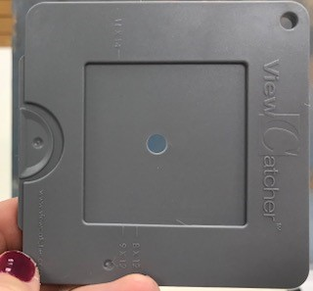

- Find the lightest light in the original. Compare this to the lightest light in you painting. Is it the same value level? Size & shape?

- Find the darkest dark in the original. Compare this to the darkest dark in you painting. Is it the same value level? Size & shape?

- Using the value scale and black & white print out, compare the values in the original versus your painting
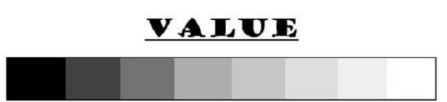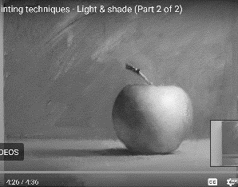

- Compare the temperature of colors (cool color versus warm color) in the original vs your painting

