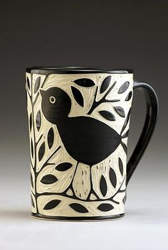

Sgraffito Vessel

Name: Class:

Place a CHECK on the score you feel you deserve

10 = Excellent, 8 = Good, 6 = Average, 4 = could improve, 2 = insufficient effort, 0 = didn’t do

Project Results - 70 Points  - You completed your vessel and sgraffito design  - Your vessel is solidly constructed with strong, scored seems that blend into the rest of the vessel  - Your vessel is smoothed without lumps and bumps  - You carved at least 50% of your surface area to be white  - Your carving is neat and smooth  - Your design is appropriate for sgraffito and is thoughtful and creative  - You completely covered you vessel with 3 coats of glaze | 0 2 4 6 8 10  0 2 4 6 8 10  0 2 4 6 8 10  0 2 4 6 8 10  0 2 4 6 8 10  0 2 4 6 8 10  0 2 4 6 8 10
Classroom Participation - 30 Points  - You used your time well and did your work with care and effort  - You listened and were silent during instruction  - You followed rules, team tasks & clean up | 0 2 4 6 8 10  0 2 4 6 8 10  0 2 4 6 8 10

