“Notes to my Younger Self” Cereal Bowl

NAME: _________________________________ CLASS: ___________________________________
Requirements:
- A written message to your younger self
- At least three symbols related to your message
- A color drawing of your design

Which construction technique will you use? PINCH COIL WHEEL

What glazing/decoration technique will you use? ___________________________________________

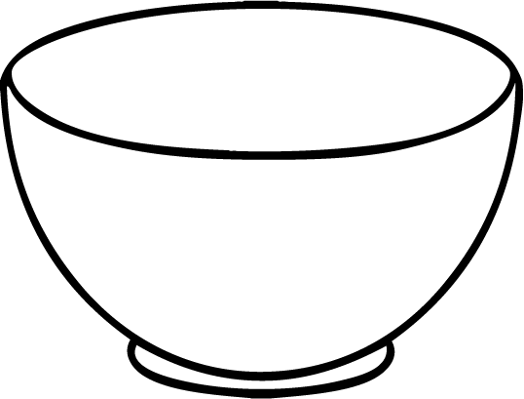
Advise I would give myself: ______________________________________________________________
Background & why:

