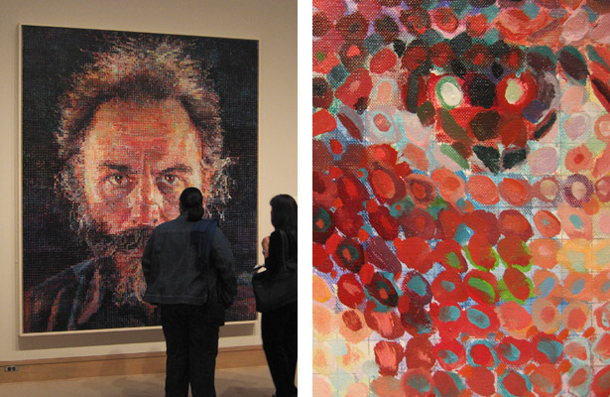

CHUCK CLOSE LESSON SUMMARY

LG1: SWBAT create piece of art in the style of Chuck Close

DAILY OBJECTIVES:
- SWBAT analyze and describe a small piece of a Chuck Close style work
- SWBAT demonstrate knowledge that, in art, “the whole can be larger than the sum of the parts”
- SW create & modify hypothesis (based on new information) as to why Chuck Close creates works like these
- SWBAT create a Chuck Close style piece of art

CURRICULUM UNIT/PROFICIENCIES:
Enduring Understandings:
- EU1: When we understand just a small part of something, we can be mindful “that the larger picture” can take on new meaning
- EU2: It is possible to take a perceived shortcoming and turn them into something spectacular

Essential Questions:
- EQ1: Are there parts of ourselves that we perceive as shortcomings that might be turned into assets?

PLANNED STRATEGIES/ACTIVITIES:
DoNow – worksheet & assembly of sample work, www.art101isaverb.com web & mobile device instruction, demonstrations, videos, scales

ASSESSMENT OF OBJECTIVES:
Diagnostic: Written assessment – intro worksheet
Formative: Daily participation/progress
Summative: Final work of art, rubric

NATIONAL CORE CURRICULIUM STANDARDS
- Responding - #7- Perceiving & analyze artistic work, #8- Interpreting intent & meaning
- Connecting - #10 – Synthesize & relate knowledge and personal experience
- Creating - # 3 – Refine & complete artistic work

MARZANO DQ FOCUS
- DQ1: Communicating learning goals
- DQ2: Helping students interact with new knowledge (#6,7,10,12,13)
- DQ4: Helping students generate & test hypotheses
- DQ5: Engaging Students

MATERIALS
- Internet www.art101isaverb.com, oil pastels, paper, worksheet, pencil, Scholastic magazine (enrichment)

