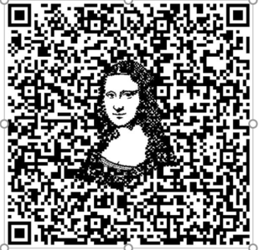
Codes to Me Assessment
Name: Period:
Cube Assessment (40 point):
 | 1 | 2 | 3 | 4 | 5
Completeness | You did not complete your cube and are missing images | You partially completed your cube and images | You complete your cube but are missing some of the 3 required images | You completed the construction of your cubes and have the 3 images but they are not in the correct panels | You completed the construction of your cube including placing all 3 images on the correct planes
Construction Quality | Most of your areas are flawed related to construction, image size or gluing | You have major areas that are flawed related to construction, image size or gluing | You have some areas that are flawed related to construction, image size or gluing | Accept for minor areas, your construction is neat and correct with the images trimmed to the correct size and completely glued down | Your construction is neat and correct with the images trimmed to the correct size and completely glued down
Movie completion | You did not complete your movie | Your movie is partially finished and you do not have a QR code | Your movie is finished but you did not make a QR code | Your movie is finished but does not link to your QR code | You completed your movie and it is viewable through your QR code
Required sections | You are missing more than four of your sections | You are missing more than three of your sections | You are missing two of your sections and/or your existing sections are not complete | While you have most of your sections. You are missing one and/or your existing sections are not complete | You fully completed all required seven sections
Creative | Your cube and movie fill the basic requirements but are not thoughtful or creative | You have the required sections but have only slightly reflected your personality creatively | Your cube and movie have limited creative elements to them | Your cube and movie are somewhat creative and thoughtful | Your cube and movie are creative and thoughtful!

Used time, care & effort | You did not utilize your time in class productively | While you were somewhat productive in class you could have used much more of your time | While you had times that were productive, you had many times that you did not utilize your time well | You had times that were productive with some minor distractions | You made productive use of every available moment in class
Listened and were silent during instruction | You were distracting while instructions were being given | You were somewhat attentive but also distracted / talking | You were attentive but missed some elements due to being distracted | You were mostly attentive with minor distractions | You were attentive while instruction were given
Followed rules, team tasks & clean up | You did not follow through with task/clean up or broke rules | You mostly followed rules and task/clean up | You followed rules and completed somewhat of your tasks/clean up | You followed rules and completed most of your tasks/clean up | Not only did you follow rules/tasks, but you also went above and beyond to be helpful

