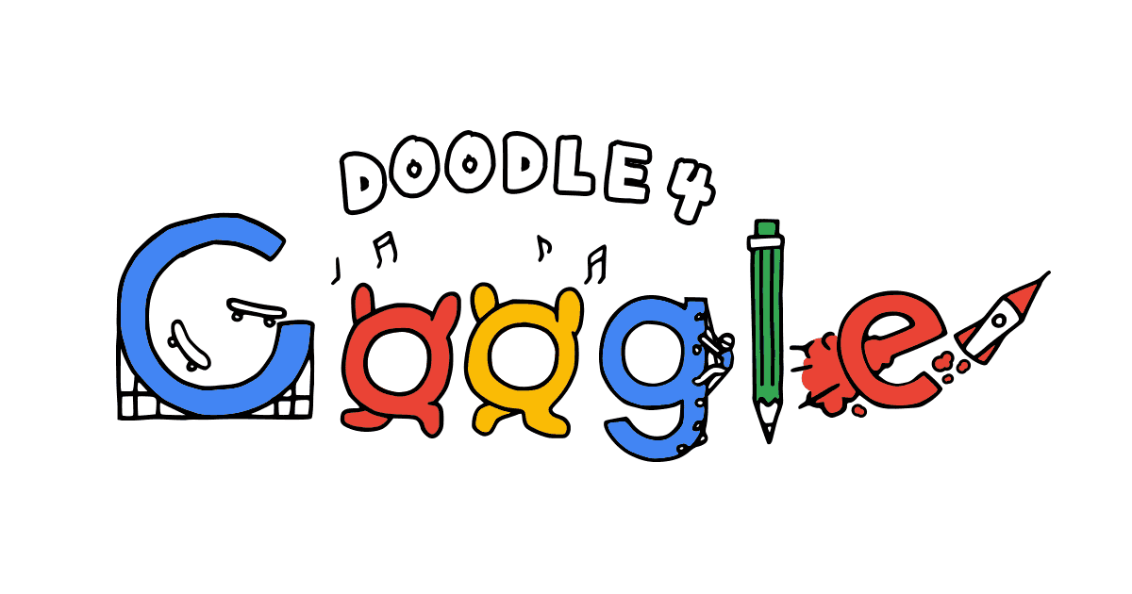
Doodle 4 Google Final Assessment
Name: Period:
Idea Assessment (45 point):
 | 1 | 2 | 3 | 4 | 5
Completeness | Completed approx. 20% | Completed approx. 40% | Completed approx. 60% | Completed approx. 80% | Completed 100% of your sculpture
Submitted to Google | You did not submit your drawing to Google |  |  |  | You submitted your drawing to Google
Idea development | You did not develop your idea to clearly communicate a vision for the future | You only slightly developed your ideas to clearly communicate a vision for the future | You somewhat developed your idea to clearly communicate a vision for the future | You mostly developed your idea to clearly communicate a vision for the future | You fully developed your idea to clearly communicate a vision for the future
Execution of Sketch | Your execution was not neat and did not communicate clearly | Your execution had major areas of flaws in neatness or communication | Your execution was relatively neat and clear communications with some areas of flaws | Your execution was mostly neat and communicated clearly with minor areas of flaws | Your execution was neat and did communicate clearly
Focal Point | The idea and Google logos are not featured together are an overall concept | While both the idea and the google logo are featured, they are significantly unequal | While both the idea and the google logo are featured, they are somewhat unequal | While both the idea and the google logo are featured, they are slightly unequal | Your idea and the Google logo are equally the focal point of your image
Creative | Your idea was not creative | Your idea was only slightly creative | Your idea was somewhat creative | Your idea was mostly creative | Your idea was very unique and creative

Used time, care & effort | You did not utilize your time in class productively | While you were somewhat productive in class you could have used much more of your time | While you had times that were productive, you had many times that you did not utilize your time well | You had times that were productive with some minor distractions | You made productive use of every available moment in class
Listened and were silent during instruction | You were distracting while instructions were being given | You were somewhat attentive but also distracted / talking | You were attentive but missed some elements due to being distracted | You were mostly attentive with minor distractions | You were attentive while instruction were given
Followed rules, team tasks & clean up | You did not follow through with task/clean up or broke rules | You mostly followed rules and task/clean up | You followed rules and completed somewhat of your tasks/clean up | You followed rules and completed most of your tasks/clean up | Not only did you follow rules/tasks, but you also went above and beyond to be helpful

