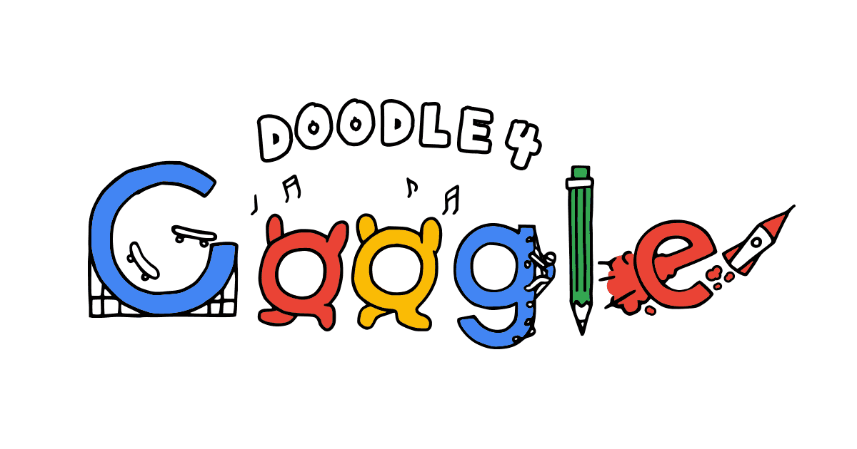
Ideas: Doodle 4 Google Assessment
Name: Period:
Idea Assessment (30 point):
 | 1 | 2 | 3 | 4 | 5
Five Ideas | You had 1 idea | You had 2 distinct ideas | You had 3 distinct ideas | You had 4 distinct ideas | You had 5 distinct ideas
Idea development | You did not develop your ideas so that they are distinct and clear | While you slightly developed your ideas, they are not clear or distinct. | While you developed your ideas, they are not fully clear or distinct. | You mostly developed your ideas to clearly communicate a vision for the future | You fully developed your ideas to clearly communicate a vision for the future
Execution of Sketch | Your execution was not neat and clear | Your execution had major areas of flaws | Your execution was relatively neat with some areas of flaws | Your execution was mostly neat and clear with minor areas of flaws | Your execution was neat and clear!

Used time, care & effort | You did not utilize your time in class productively | While you were somewhat productive in class you could have used much more of your time | While you had times that were productive, you had many times that you did not utilize your time well | You had times that were productive with some minor distractions | You made productive use of every available moment in class
Listened and were silent during instruction | You were distracting while instructions were being given | You were somewhat attentive but also distracted / talking | You were attentive but missed some elements due to being distracted | You were mostly attentive with minor distractions | You were attentive while instruction were given
Followed rules, team tasks & clean up | You did not follow through with task/clean up or broke rules | You mostly followed rules and task/clean up | You followed rules and completed somewhat of your tasks/clean up | You followed rules and completed most of your tasks/clean up | Not only did you follow rules/tasks, but you also went above and beyond to be helpful

