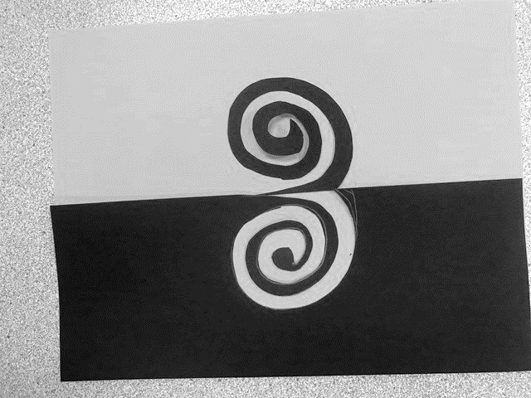
Positive Negative Space
3 Exercises: Half, Square & Pattern
Name: Period:

Project Assessment (40 point):
 | 1 | 2 | 3 | 4 |  | 5
Completion | You completed less than two exercises | You completed two exercises | You somewhat completed all three exercises with some major areas missing |  | You mostly completed all three exercises with some minor areas missing | You fully completed all three exercises
Half exercise | You did not achieve a positive negative space effect and/or did not divide your space in half | You only slightly achieve a positive negative space effect and/or did not divide your space in half | Your half exercise activates some of the space and mostly creates an overall positive negative effect |  | Your half exercise activates most of the space and creates an overall positive negative effect | Your half exercise activates the entire space and creates an overall impactful image
Square exercise | You did not achieve a positive negative space effect and/or did not utilize all sides of the square | Your square exercise slightly activates the space and but lacks a positive negative space effect | Your square exercise slightly activates the space and creates a somewhat impactful positive negative space effect |  | Your square exercise somewhat activates the entire space and creates a somewhat impactful positive negative space effect | Your square exercise activates the entire space and creates a impactful positive negative space effect
Pattern exercise | You did not achieve a positive negative space effect and/or did not utilize a pattern | Your pattern exercise slightly activates the space and but lacks a positive negative space effect | Your pattern exercise slightly activates the space and creates a somewhat impactful positive negative space effect |  | Your pattern exercise activates most of the space and creates a somewhat impactful positive negative space effect | Your pattern exercise activates the entire space and creates a impactful positive negative space effect
Craftsmanship | Your cutting and gluing and placement was not neat and prevents you from achieving the overall effect | Your cutting and gluing and placement lacks neatness and distracts from your work | Your cutting and gluing and placement was somewhat neat but distracts slightly |  | Your cutting and gluing and placement was neat with minor imperfections and mostly enhances your design | Your cutting and gluing and placement was neat and enhances your design

Used time, care & effort | You did not utilize your time in class productively | While you were somewhat productive in class you could have used much more of your time | While you had times that were productive, you had many times that you did not utilize your time well | You had times that were productive with some minor distractions | You made productive use of every available moment in class
Listened and were silent during instruction | You were distracting while instructions were being given | You were somewhat attentive but also distracted / talking | You were attentive but missed some elements due to being distracted | You were mostly attentive with minor distractions | You were attentive while instruction were given
Followed rules, team tasks & clean up | You did not follow through with task/clean up or broke rules | You mostly followed rules and task/clean up | You followed rules and completed somewhat of your tasks/clean up | You followed rules and completed most of your tasks/clean up | Not only did you follow rules/tasks, but you also went above and beyond to be helpful

