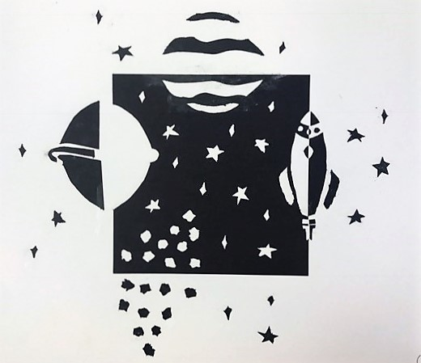
Positive Negative Space
Scene or Theme Final
Name: Period:

Project Assessment (35 point):
 | 1 | 2 | 3 | 4 |  | 5
Completeness | Completed approx. 20% | Completed approx. 40% | Completed approx. 60%. |  | Completed approx. 80%. | Completed 100% , all of your pages
Executed sketch & detail | Your final design does not represents your sketch and/or lacks detail | Your final design only slightly represents your sketch and includes little detail | Your final design somewhat represents your sketch and includes some detail |  | Your final design mostly represents your sketch and includes most detail | Your final design accurately represents your sketch and includes all detail
Craftsmanship | You took little effort in creative your work | Your craftsmanship is detracts from your work | Your craftsmanship is decent with some imperfections |  | Your craftsmanship is good with minor imperfections | Your craftsmanship is perfect
Design Impact & Space activation | Your design does not activates the entire area or create an impactful scene or theme | Your design slightly activates the entire area and slightly creates an impactful scene or theme | Your design somewhat activates the entire area and creates a somewhat scene or theme |  | Your design mostly activates the entire area and creates a mostly impactful scene or theme | Your design activates the entire area and clearly creates an impactful scene or theme

Used time, care & effort | You did not utilize your time in class productively | While you were somewhat productive in class you could have used much more of your time | While you had times that were productive, you had many times that you did not utilize your time well | You had times that were productive with some minor distractions | You made productive use of every available moment in class
Listened and were silent during instruction | You were distracting while instructions were being given | You were somewhat attentive but also distracted / talking | You were attentive but missed some elements due to being distracted | You were mostly attentive with minor distractions | You were attentive while instruction were given
Followed rules, team tasks & clean up | You did not follow through with task/clean up or broke rules | You mostly followed rules and task/clean up | You followed rules and completed somewhat of your tasks/clean up | You followed rules and completed most of your tasks/clean up | Not only did you follow rules/tasks, but you also went above and beyond to be helpful

