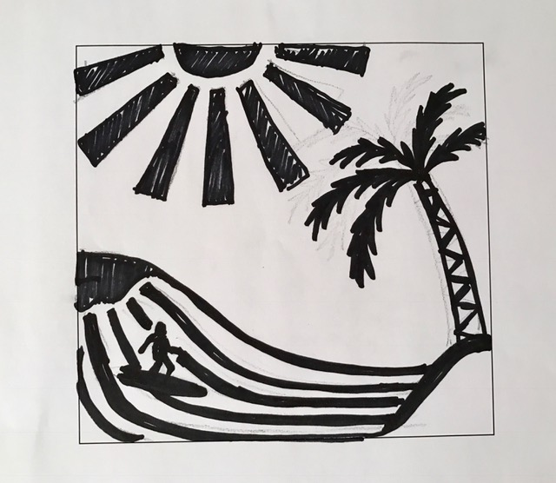
Positive Negative Space
Thumbnail Sketches & Final Design Drawing
Name: Period:

Project Assessment (30 point):
 | 1 | 2 | 3 | 4 |  | 5
Number of ideas | You did not explore other ideas | You came up with two slightly different ideas | You came up with two different ideas |  | You came up three slightly different ideas | You came up with at least three different ideas
One idea development | You did not develop your idea | You only slightly developed your idea | You only somewhat developed your idea |  | You developed one idea trying several modifications but could have gone a bit further | You fully developed one idea trying several modifications
Small black/white transfer paper | You didn’t completed and accurately showed your design in blk/wht on tracing paper | You only slightly completed and accurately showed your design in blk/wht on tracing paper | You somewhat completed and accurately showed your design in blk/wht on tracing paper |  | You mostly completed and accurately showed your design in blk/wht on tracing paper | You completed and accurately showed your design in blk/wht on tracing paper
Design Impact | Your design does not activates the entire area or create a scene or theme | Your design slightly activates the entire area and slightly creates a scene or theme | Your design somewhat activates the entire area and somewhat creates a scene or theme |  | Your design mostly activates the entire area and creates a scene or theme | Your design activates the entire area and clearly creates a scene or theme

Used time, care & effort | You did not utilize your time in class productively | While you were somewhat productive in class you could have used much more of your time | While you had times that were productive, you had many times that you did not utilize your time well | You had times that were productive with some minor distractions | You made productive use of every available moment in class
Listened and were silent during instruction | You were distracting while instructions were being given | You were somewhat attentive but also distracted / talking | You were attentive but missed some elements due to being distracted | You were mostly attentive with minor distractions | You were attentive while instruction were given
Followed rules, team tasks & clean up | You did not follow through with task/clean up or broke rules | You mostly followed rules and task/clean up | You followed rules and completed somewhat of your tasks/clean up | You followed rules and completed most of your tasks/clean up | Not only did you follow rules/tasks, but you also went above and beyond to be helpful

