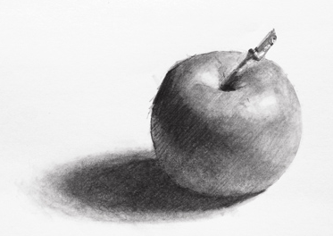
Shaded Drawings
Final Assessment
Name: Period:
Assessment (45 point):
 | 1 | 2 | 3 | 4 | 5
Completeness | Completed approx. 20% | Completed approx. 40% | Completed approx. 60%, | Completed approx. 80%, | Completed 100%
Grid Representation | Your drawing is not recognizable | Because of its incompleteness or inaccuracy, your drawing only has s slight resemblance | Your drawing looks just like your reference with some inaccuracies | Your drawing looks just like your reference with only some minor inaccuracies | Your drawing looks just like your reference
Value Scale | You have less than 30% of the value scale represented | You have about 40% of the value scale represented with some major inaccuracies in the placement/proportions | You have about 60% of the value scale represented with some inaccuracies in the placement/proportions | You have most of the full value scale with some minor inaccuracies in the placement/proportions | Your darks and lights represent the full range of the value scale and in the correct placement/proportion
Blending | You did not blend effectively | While you have some blending, you have many areas that are not blended or have “jumps” | You are mostly blended with some areas of “jumps” or unblended lines | You blended accurately with only minor areas of” jumps” | Your drawing is beautifully blended to emphasize areas of focus
Form & Depth Creation | You did not show form through shading | While you have some shaded areas, they do little to create a 3D effect | Your shading enhances your 3D representation with some major weak areas | Your shading enhances your 3D representation with some minor weak areas | Your shading maximizes your 3D representation
No Outline | You did not eliminated outlines and defined your edge with shading | You only slightly eliminated outlines and defined your edge with shading | You somewhat eliminated outlines and defined your edge with shading | You mostly eliminated outlines and defined your edge with shading | You eliminated outlines and defined your edge with shading

Time on Task | You did not utilize your time in class productively | While you were somewhat productive in class you could have used much more of your time | While you had times that were productive, you had many times that you did not utilize your time well | You had times that were productive with some minor distractions | You made productive use of every available moment in class
Effort and Perseverance | You did not continued to persevere and gave up without exhausting resources | You only slightly continued to persevere and apply consistent effort in order to achieve goal using resources as needed | You mostly continued to persevere and apply consistent effort in order to achieve goal using resources as needed | You somewhat continued to persevere and apply consistent effort in order to achieve goal using resources as needed | You continued to persevere and apply consistent effort in order to achieve goal using resources as needed
Class rules & clean up | You did not follow through with task/clean up or broke rules | You mostly followed rules and task/clean up | You followed rules and completed somewhat of your tasks/clean up | You followed rules and completed most of your tasks/clean up | Not only did you follow rules/tasks, but you also went above and beyond to be helpful

