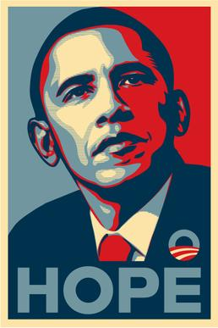

Mural : Shepard Fairey

Name:_________________________ Block:__________________

List three things that you notice about this image:

1

2

3

The “Obey” stickers became popular without meaning anything… just by exposure (it being seen all over the place). What in your life and environment seem to also to be popular without having lots of meaning behind it? Explain your answer.

