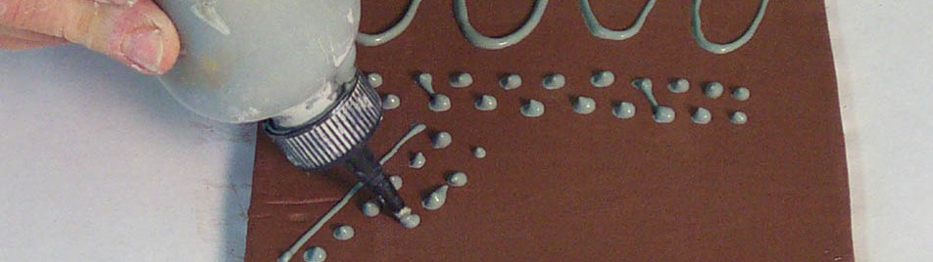
Slip Trail Assessment
Name: Period:
Project Assessment (40 point):
 | 1 | 2 | 3 | 4 | 5
Completeness | Completed approx. 20% | Completed approx. 40% | Completed approx. 60% | Completed approx. 80% | Completed 100%, and it reflects your sketch
Thought out sketch | Little effort was made & drawing/photo is lacking enough information to build vessel | Your sketch has significant areas that are not addressed and unresolved | You completed your sketch but there are some unresolved issues with your design | You have most of the information that you need with some minor issues unresolved | Your sketch/photo is well thought out and addresses any construction issues you might have
Well-constructed  vessel | Little effort was made in constructing a solid vessel | Your vessel’s construction is weak due to poor construction techniques | Your vessel’s construction holds together but has several weak areas | Your vessel construction is solid with minor areas of weakness | You successfully constructed you vessel with not air bubbles
Slip Trail Technique | Your slip trail is inconsistent , distracting and does not activate your vessel | Your slip trail has areas of inconsistency , and only somewhat activates your vessel | Your slip trail is applied somewhat consistently creating a somewhat round ridge and activates most of the entire vessel | Your slip trail is applied mostly consistently creating a mostly round ridge and activates nearly the entire vessel | Your slip trail is applied consistently creating a round ridge and activates the entire vessel
Creative | Your vessels is common and does not reflect creative thinking | Your vessel has been done before but is more than just a traditional construction | Your vessel is more traditional with minor areas of creativity | Your vessels is relatively unique and with somewhat traditional techniques | Your vessels is impressively unique and you used your construction creatively

Used time, care & effort | You did not utilize your time in class productively | While you were somewhat productive in class you could have used much more of your time | While you had times that were productive, you had many times that you did not utilize your time well | You had times that were productive with some minor distractions | You made productive use of every available moment in class
Listened and were silent during instruction | You were distracting while instructions were being given | You were somewhat attentive but also distracted / talking | You were attentive but missed some elements due to being distracted | You were mostly attentive with minor distractions | You were attentive while instruction were given
Followed rules, team tasks & clean up | You did not follow through with task/clean up or broke rules | You mostly followed rules and task/clean up | You followed rules and completed somewhat of your tasks/clean up | You followed rules and completed most of your tasks/clean up | Not only did you follow rules/tasks, but you also went above and beyond to be helpful

