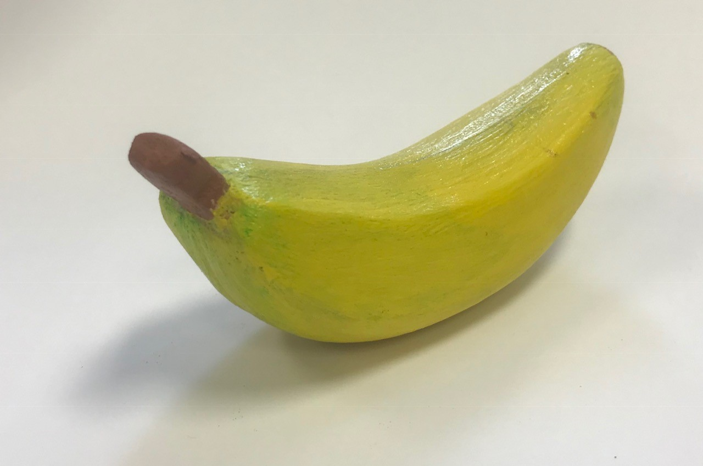
Small Sculpture Assessment
Name: Period:
Sculpture Assessment (40 point):
 | 1 | 2 | 3 | 4 | 5
Complete carving | You completed less than 30% of your intended design | You completed approx. 30% of your intended design | You completed 50% of your sculpture based on your design | You completed approx. 80% of your sculpture based on your design | You completed 100% of your sculpture based on your design
Form Creation | Your sculpture has a minimum amount of FORM creation | While you have some FORM creation, much of your sculpture still has flat sides | You create some FORM but still have some areas of flatness | Overall you created mostly FORM but still have minor areas of flatness | Your sculpture emphasizes the element of FORM in all directions & minimizes the flatness of sides
Smoothing | You did not significantly smooth your sculpture | You smoothed your sculpture to eliminate all carving and scratch marks but have some major areas of flaws | You smoothed your sculpture to remove all carving and scratch marks with some flaws | You smoothed your sculpture to remove all carving and scratch marks with some minor flaws | You smoothed your entire sculpture to eliminate all carving and scratch marks to completely smooth finish
Finish | You did not apply surface treatment in a highly creative thoughtful way | You only slightly applied surface treatment in a highly creative thoughtful way | You somewhat applied surface treatment in a highly creative thoughtful way | You mostly applied surface treatment in a highly creative thoughtful way | You applied surface treatment in a highly creative thoughtful way
Creative | Your sculpture fills the basic requirements but are not thoughtful or creative | You have the required carving but have only slightly reflected your personality creatively | Your sculpture has limited creative elements | Your sculpture is somewhat creative and thoughtful | Your sculpture is creative and thoughtful!

Used time, care & effort | You did not utilize your time in class productively | While you were somewhat productive in class you could have used much more of your time | While you had times that were productive, you had many times that you did not utilize your time well | You had times that were productive with some minor distractions | You made productive use of every available moment in class
Listened and were silent during instruction | You were distracting while instructions were being given | You were somewhat attentive but also distracted / talking | You were attentive but missed some elements due to being distracted | You were mostly attentive with minor distractions | You were attentive while instruction were given
Followed rules, team tasks & clean up | You did not follow through with task/clean up or broke rules | You mostly followed rules and task/clean up | You followed rules and completed somewhat of your tasks/clean up | You followed rules and completed most of your tasks/clean up | Not only did you follow rules/tasks, but you also went above and beyond to be helpful

