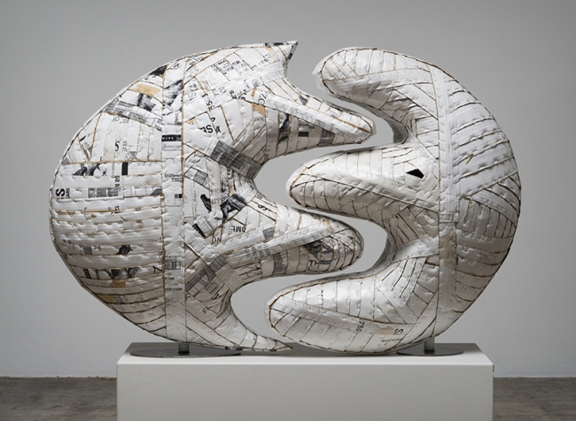
Wood Sculpture - Final Assessment
Name: Period:
Project Assessment (40 point):
 | 1 | 2 | 3 | 4 | 5
Completion | You completed less than 30% of your intended design | You completed approx. 30% of your intended design | You completed 50% of your sculpture based on your design | You completed approx. 80% of your sculpture based on your design | You completed 100% of your sculpture based on your design
Construction craftsmanship | Your construction is not neat and sturdy | Your construction is only slightly neat and sturdy | Your construction is somewhat neat and sturdy | Your construction mostly is neat and sturdy | Your construction is neat and sturdy
Negative Space | You did not created negative space to enhances your sculpture | You only slightly created negative space to enhances your sculpture | You somewhat created negative space to enhances your sculpture | You mostly created negative space to enhances your sculpture | You created negative space that enhances your sculpture
Balance | You achieved neither symmetrical or asymmetrical balance | You only slightly achieved either symmetrical or asymmetrical balance | You somewhat achieved either symmetrical or asymmetrical balance | You mostly achieved either symmetrical or asymmetrical balance | You successfully achieved either symmetrical or asymmetrical balance
Surface Finishing | Your finishing treatment was not inspired by a famous artist and/or enhances your design | Your finishing treatment was only slightly inspired by a famous artist and/or enhances your design | Your finishing treatment was somewhat inspired by a famous artist and/or enhances your design | Your finishing treatment was mostly inspired by a famous artist and enhances your design | Your finishing treatment was inspired by a famous artist and enhances your design

Used time, care & effort | You did not utilize your time in class productively | While you were somewhat productive in class you could have used much more of your time | While you had times that were productive, you had many times that you did not utilize your time well | You had times that were productive with some minor distractions | You made productive use of every available moment in class
Listened and were silent during instruction | You were distracting while instructions were being given | You were somewhat attentive but also distracted / talking | You were attentive but missed some elements due to being distracted | You were mostly attentive with minor distractions | You were attentive while instruction were given
Followed rules, team tasks & clean up | You did not follow through with task/clean up or broke rules | You mostly followed rules and task/clean up | You followed rules and completed somewhat of your tasks/clean up | You followed rules and completed most of your tasks/clean up | Not only did you follow rules/tasks, but you also went above and beyond to be helpful

